A CVMC Mineral Case was presented to Sandy Honiban, Principal of St Thomas The Apostle School in
West Springfield, MASS
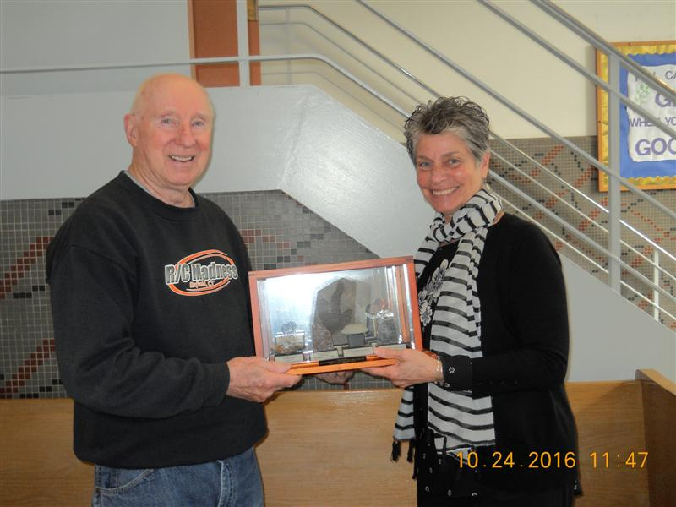
Jack Marcy

