A CVMC Mineral Case was presented to Maria Sansalone a teacher at Neari School of Holyoke MASS
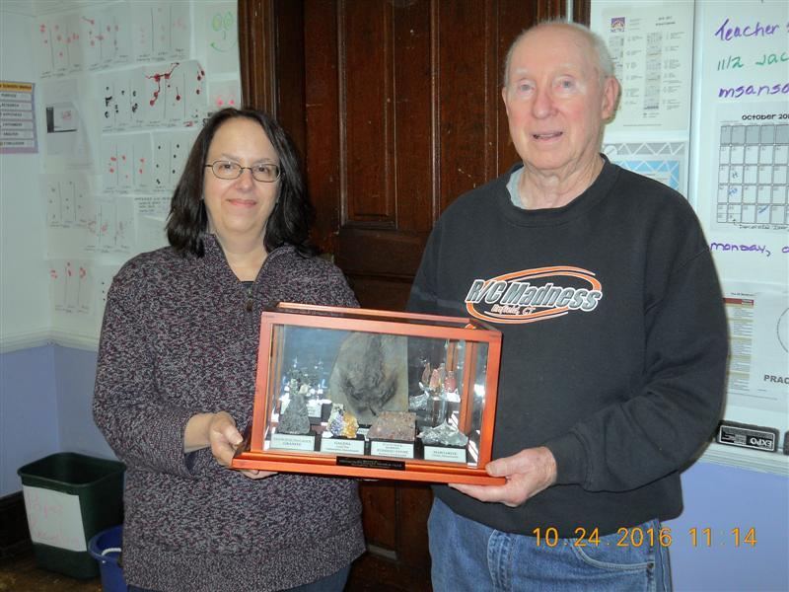
Jack Marcy

