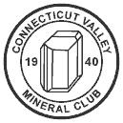

Connecticut Valley Mineral Club
Springfield, Massachusetts

The Connecticut Valley Mineral Club endeavors to foster a sense of community as well as an enthusiastic exchange of knowledge and ideas centering around fossils, rocks, and minerals. Field study of mineralogical and geological features of the Connecticut Valley and its vicinity is encouraged, as is the search for new minerals. Knowledgeable club members provide help and instruction to beginning collectors in areas such as mineral collecting, specimen preparation, and lapidary skills, and the Club promotes a standard for responsible rock hunting. These objectives are the heart and foundation of our active and growing Club. Families are welcome to join. Connecticut Valley Mineral Club meetings are held the first Wednesday of most months, September through June. For more about meeting location and membership, visit our website: www.cvmineralclub.org.

Copyright Information

This guide to Significant Rocks and Minerals of Massachusetts, and the Massachusetts Mineral School Display Case accompanying it, was prepared by theConnecticut Valley Mineral Club, Springfield,Massachusetts, and presented to area public schools and other interested groups as part of the Club’s ongoing commitment to stimulate discovery and exploration of geological science.

Copyright ©2014 All Rights Reserved.

SIGNIFICANT

ROCKS

AND

MINERALS

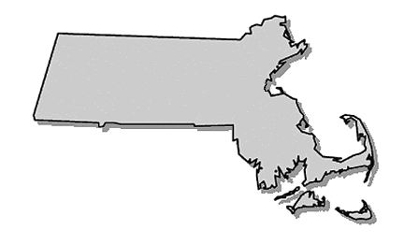FROM MASSACHUSETTS

Presented by the
Connecticut Valley Mineral Club
Springfield, Massachusetts
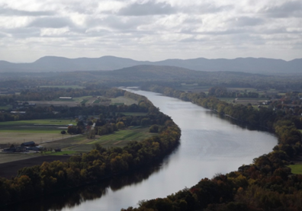
Andy Brodeur Photo

Introduction

This booklet, along with a mineral display case containing “Significant Rocks and Minerals from Massachusetts” was designed and produced by the Connecticut Valley Mineral Club. Our project began in 2009 with a display case, booklet and educational presentation to bring the wonder of rocks and minerals to the public. Our continuing goal is to stimulate an awareness and interest in Geology and Mineralogy.

The Rocks and Minerals featured in this booklet were chosen because they are significant to Massachusetts, are an official state Earth Symbol, or because of their rarity. In addition, the last pages in the booklet list all known minerals from Massachusetts to date.

Rocks and minerals are items of beauty collected by millions of people worldwide. We invite you to step into the world of minerals and look at them as more than just rocks. If it weren’t for minerals none of the things we enjoy today would be here, even people!

We hope this booklet answers questions as well as provoking new ones. Have fun on your mineral journey…
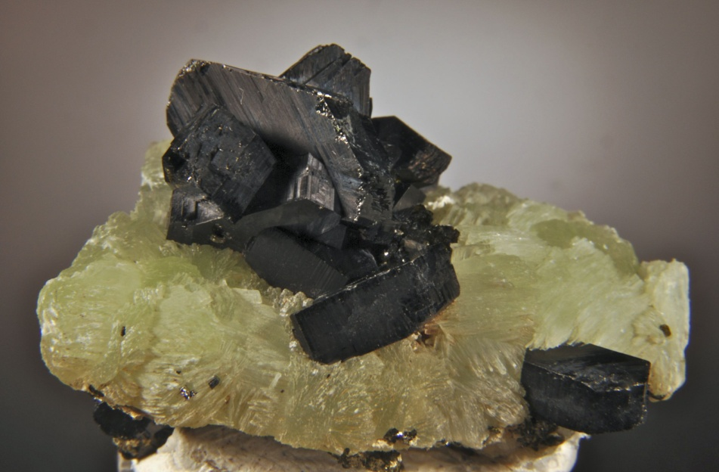
Kevin Downey Photo
BABINGTONITE
Official Massachusetts State Mineral

Massachusetts is one of the few locations in the world where Babingtonite has been found. It appears as small wedge-shaped black crystals that belong to a class of minerals called Silicates. They have a Mohs hardness of 5 - 6 with good prismatic cleavage and uneven fracture. Crystals of Babingtonite growing with Prehnite and Calcite can be found lining basalt, gneiss or granite cavities.

Massachusetts has produced some of the best specimens found in the United States. Several locations exist in the State, but the best have been found in a basalt quarry in Westfield. Babingtonite is sought by mineral collectors and mineralogists.

Babingtonite was first analyzed and documented in 1824 as a new mineral, when specimens were discovered in Norway. It was named after William Babington who was born in Ireland and became a respected physician and mineralogist residing in England. He was the founding member and president of the Geological Society of London. Massachusetts adopted Babingtonite as our official State Mineral in 1971.

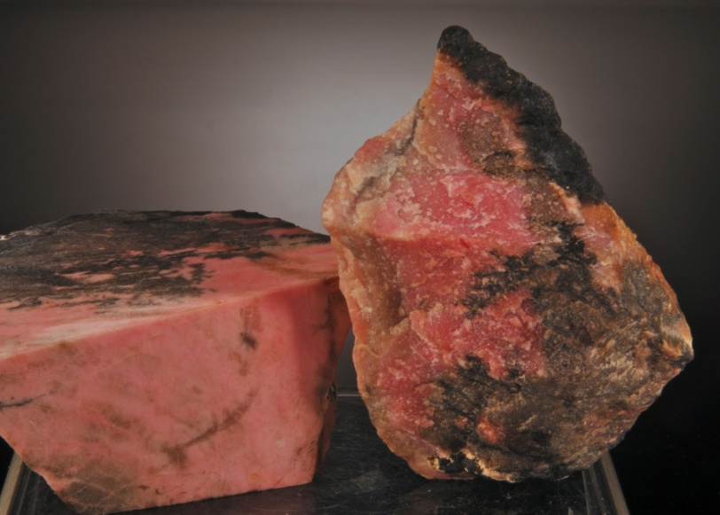
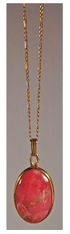
Kevin Downey Photo

RHODONITE
Official Massachusetts State Gemstone

Named after the Greek word for rose, (rhodon), Rhodonite was found on a property in Plainfield, Massachusetts and mining took place starting about 1925. This is the only known location in Massachusetts where Rhodonite is found.

It is a Silicate mineral that is formed in Metamorphic Rocks and is often found associated with black manganese. It varies in color from a deep pink, to pale pink and also brown, but it’s the distinctive rose-pink color that is highly prized by collectors and jewelry makers.

Massachusetts designated Rhodonite as its official state gemstone in 1979. Rhodonite has a Mohs hardness of 5.5 – 6.5 and is usually translucent taking a good polish. . Lapidary artists use Rhodonite to create stunning cabochon jewelry and ornamental carvings.

Rhodonite was used as early as the 19th century as a decorative adornment for knife and umbrella handles as well as dinnerware. There is a place setting on display in the American Museum of Natural History in New York City.
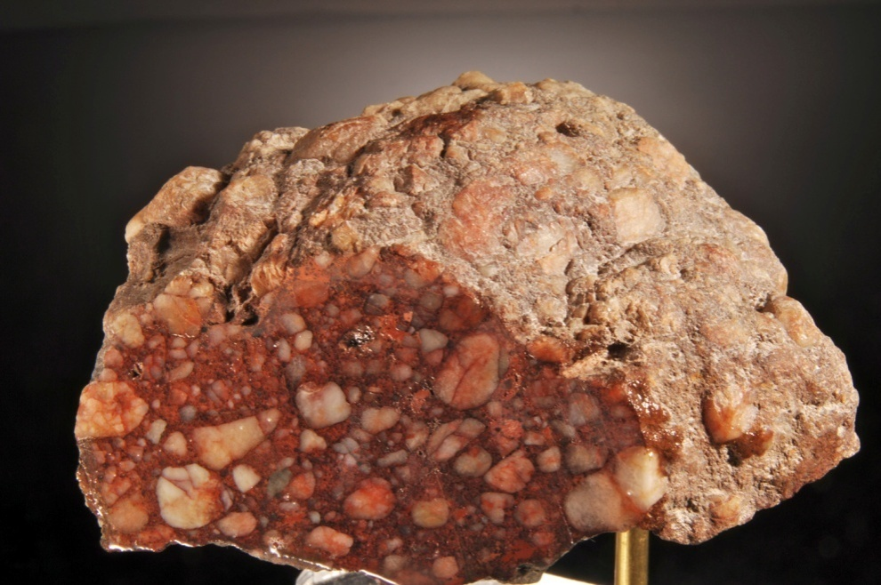
ROXBURY PUDDINGSTONE
Official Massachusetts State Stone
Kevin Downey Photo
Roxbury Puddingstone is the State Rock of Massachusetts. Roxbury puddingstone is principally found in the Roxbury section of Boston. It was called puddingstone due to its resemblance to an old fashioned fruit filled pudding. It is a Conglomerate rock made up of a mixture of different, irregular sized grains and pebbles held together by a finer matrix, usually formed from Quartz sand. This Sedimentary Rock was formed by ancient glacial river deposits and may contain other minerals such as Chromite, Corundum, Platinum, Diamonds, Gold, Sapphire, and Zircon. Puddingstone was a very popular building material in the 19th century, replacing red brick as a material of choice and can be seen in many buildings in the Boston area. It is getting very hard to find this rock today, because road and building construction has covered it over. Roxbury Puddingstone, sometimes called Roxbury Conglomerate, became the state rock or rock emblem of the Commonwealth on May 23, 1983.
Kevin Downey Photo

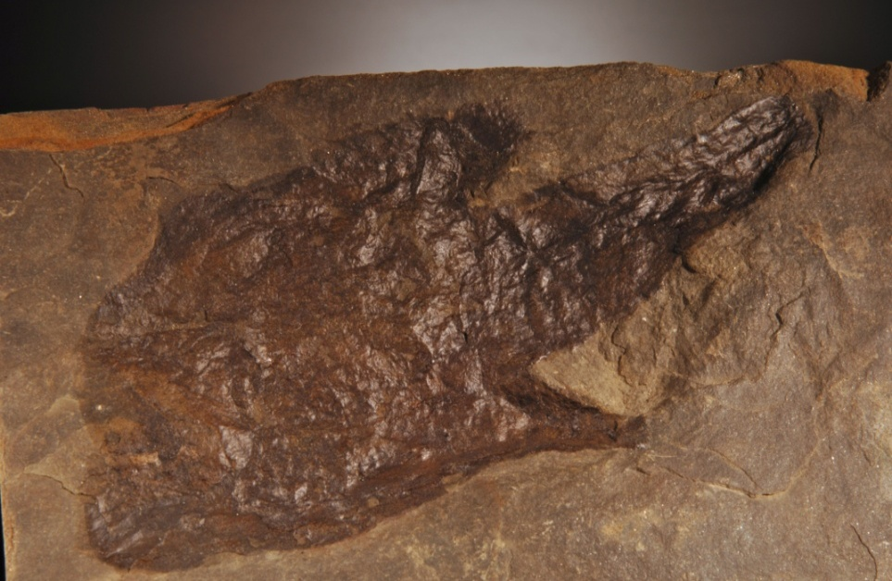
Kevin Downey Photo
DINOSAUR TRACKS
Official Massachusetts State Fossil
The Connecticut River Valley is world famous for its abundance of 200 million year old Dinosaur Footprints.In 1802 a farmer by the name of Pliny Moody was plowing his field and happened to turn over a rock which had tracks embedded in it. At the time he had no idea what it was, but in 1833, Professor Edward Hitchcock of Amherst College claimed an ancient bird made them. Years later, they were discovered to be made by animals described as dinosaurs. The Connecticut River Valley was actually the location of a few large lakes, which were visited by many different dinosaurs (Eubrontes, Grallator and Anchisaurus). The tracks they left behind in the mud, over time became Sedimentary Rock.
Amherst College has a very large collection of Dinosaur Tracks recovered from the western Massachusetts area and many are on display in the college’s state-of-the-art Museum of Natural History and are free for viewing. The State Legislature adopted the Dinosaur Track as the official State fossil in 1980.

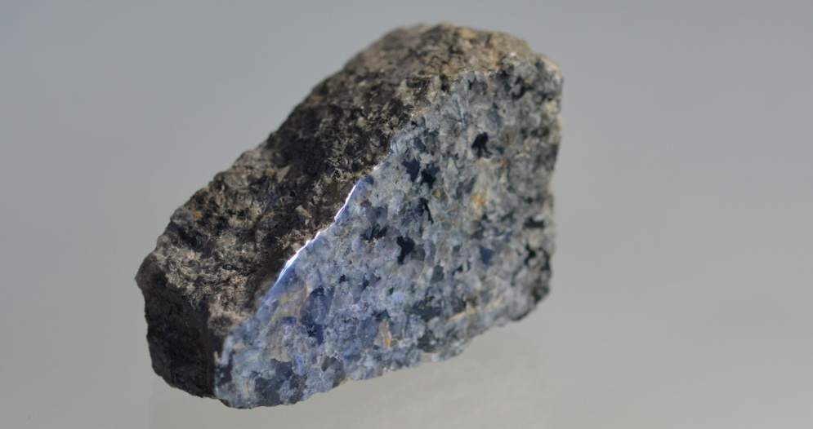
GRANITE
Fred Wilda Photo
Official Massachusetts State Building Stone

Granite is an Igneous Rock most commonly consisting of Quartz, Feldspar, and Mica. Its color can vary from shades of gray, white, pink, yellow, and, in rare cases, green. Granite is very durable and plentiful. It takes a beautiful polish giving it many uses beyond a popular building stone; from counter tops to pen holders. Granite is mined in several locations in Massachusetts. Quincy Granite was an exceptionally nice dark gray color and was chosen for the building of the Bunker Hill Monument, the Washington Monument, and the Massachusetts Veterans Memorial on Mount Greylock in North Adams, MA. Granite was made the building and monument stone of the Commonwealth on May 23, 1983.

Mineral Display Cases that include Quincy Granite are authentic Quincy Granite from the original quarry property in Quincy, MA. These samples were graciously donated by the Massachusetts Department of Conservation and Recreation (DCR). This Granite was collected with written permission from the DCR to the Connecticut Valley Mineral Club for educational purposes. It is an offense to take, remove, deface, destroy, tamper with or disturb any plant life, geological features or cultural resources on state property in Massachusetts.

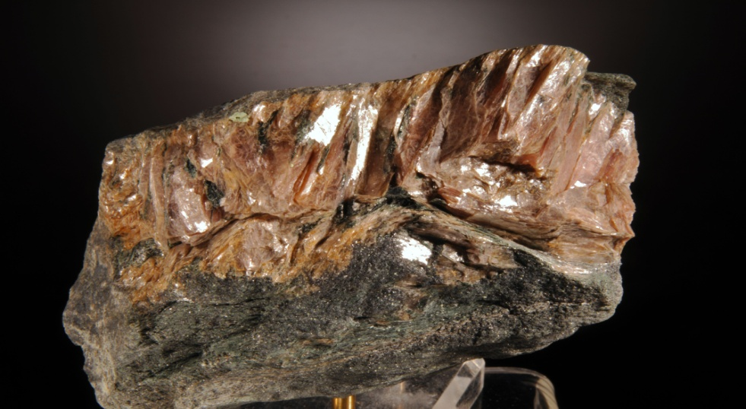
Kevin Downey Photo
MARGARITE

Margarite was first discovered in 1864 by Dr. H. S. Lucas in the town of Chester, where a very rich emery deposit was found and a mining operation called the Chester Emery Mines was started. Margarite is a pink colored mineral that is usually found with Corundum in Emery deposits. It is a Calcium, Aluminum Silicate that very closely resembles Mica, but is harder. Emery was mined to make abrasive products such as grinding wheels and wet stones and also ground to produce a type of sandpaper called Emery Cloth. The Chester Emery Mines was the first emery mine in the United States. Mining operations finally ended in 1913 because of less expensive sources of Emery found outside the country. Margarite can still be collected there today along with about 40 other minerals. Collectors have been visiting the Chester Emery Mines for many years to dig through the discarded material known as “tailings” or “dumps”. Margarite is not one of the State earth symbols but it is significant to the mining history of Massachusetts. Margarite from this location is said to be the best found in the United States. This property is currently owned by the Massachusetts Department of Fisheries and Wildlife and permission is needed for collecting.

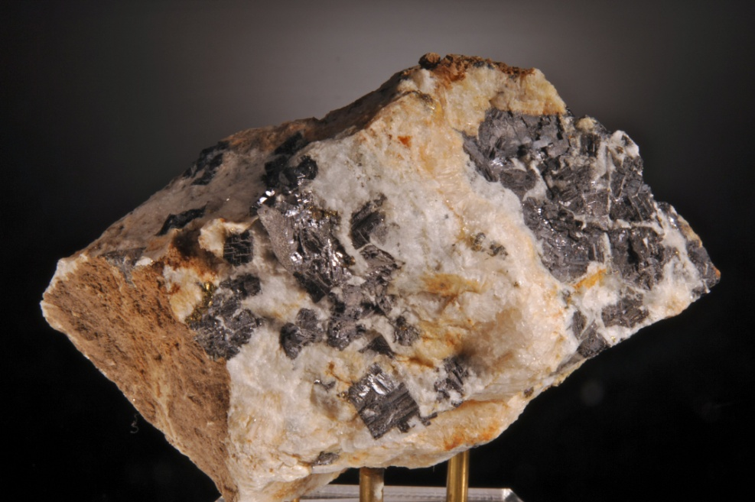
Kevin Downey Photo
GALENA

Galena is a dark gray metallic mineral and the principal Ore of Lead. A farmer by the name of Robert Lyman made the discovery of a very rich deposit of Galena in 1678 while hunting. Currently, the mine is located in the Village of Loudville, between Easthampton and Southampton in Western Massachusetts. Lead was a necessity to the early settlers for use in their firearms both for protection and to acquire food. The Ore was also very rich in Silver, containing about 12 ounces of Silver per ton of Lead. The mine in Loudville remained in operation for many years supplying Lead for musket balls for the American Revolution and for decades thereafter. Ethan Allen of Vermont worked the mines from 1765–1770. The mine was known as the Manhan Mines, named after the Manhan River, which runs adjacent to the mines.

Some areas of the original dumps are still open to collecting. At least 32 different minerals have been found here to date. The most popular are the many varieties of habits and colors of Wulfenite, Quartz, Pyromorphite, Cerussite and Barite crystals.

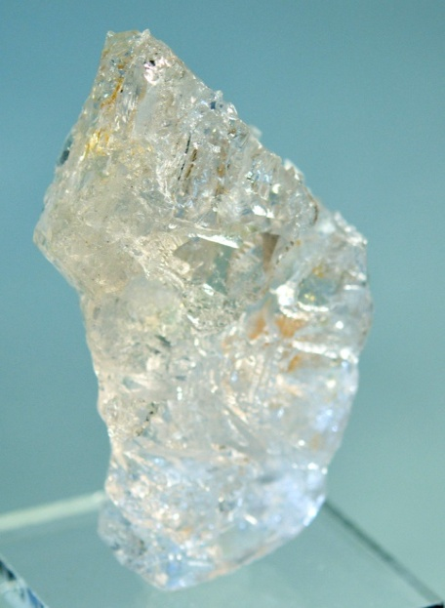
GOSHENITE

Goshenite is primarily found in Pegmatites. It is the colorless variety of the Beryl mineral group. It is also known as "white Beryl" or "mother of gemstones." This type of Beryl was once used in eyeglasses. It was first verified as a colorless Beryl in Goshen, MA, and can also be found in Russia, Brazil, Pakistan, Madagascar, and other locations around the world.The base elements found in this stone are Beryllium, Aluminum, and Silicon.
Fred Wilda Photo

Popular Beryls like Emeralds (green Beryl), Heliodor (yellow Beryl), Morganite (pink Beryl), and Aquamarine (blue Beryl), are a result of trace elements in Goshenite.

CUMMINGTONITE
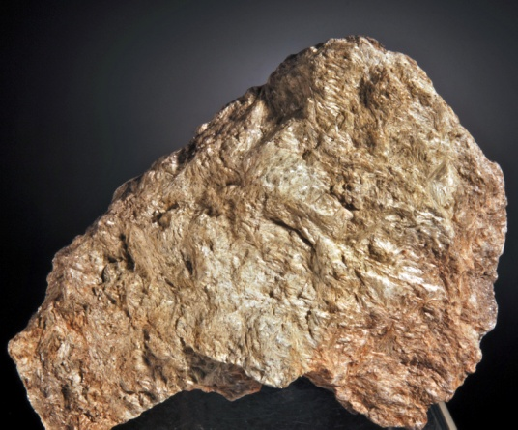
This mineral was originally discovered in 1812 on a property in Cummington, MA. It is a Magnesium Iron Silicate Hydroxide found in Metamorphic Rocks. It commonly occurs as aggregates of fibrous crystals, often in radiating clusters.
Kevin Downey Photo

Cummingtonite is transparent to translucent, varies in color from white to green to brown, and may be pale to dark depending primarily on the Iron content and is part of the Amphibole group.
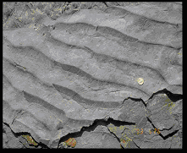
Andy Brodeur Photo
SEDIMENTARY RIPPLE STONES
Ripple marks are not Fossils but are a very common sedimentary structure and are found in the same Sedimentary Rock formations as Fossils. They come in two forms, symmetric, or wave formed ripples. Wave-formed ripple result from the to-and-fro motion of waves and have a symmetrical profile. The other type is asymmetric, or current ripples. Current ripple marks form in response to water or wind currents flowing in one direction and have asymmetric profiles. Geologists can determine the Paleo current directions by studying the ripples, in other words the frequency or space between the ripples is directly related to speed and depth of the water at the time the ripples were made as well as the direction that the wind and water was flowing from when the cross beds were deposited. The ripple marks that can be found in Western MA are known to be from the Jurassic Period roughly 200 million years old.
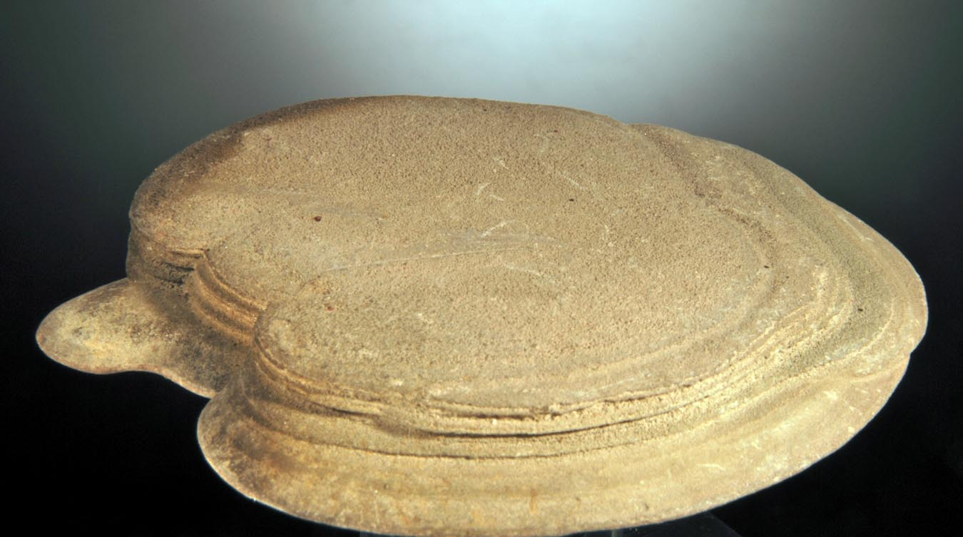

Kevin Downey Photo

CLAY CONCRETIONS

Clay Concretions are hard, unusually shaped sedimentary structures of clay and silt. These structures formed in delta areas where streams ran into glacial lakes. These formations are not as old as some minerals in the area, forming around the time of the last ice age about 15,000 years ago. The sediments are held together by the mineral called Calcium Carbonite that functions like a natural glue. Native Americans who lived along the Connecticut River in Hampshire County called them “puddle stones” and may have used them as money or jewelry for ceremonies. Over thousands of years they hardened into the shapes we find today. The Hadley and Hatfield areas are known for having some of the nicest concretions in the country where they are found under water in the Connecticut River. The concretions can range in size from 1 inch to 4 or 5 inches across and are regularly sought by divers and collectors today.

Hundreds of unusually shaped Clay Concretions were found at the University of Massachusetts, Amherst Campus, during excavating work for a new water treatment plant. These were found in a variety of shapes and sizes and are unlike the Connecticut River discs. They appear to be made of the same clay material.

THE MYSTERY OF THE

“RUSSELL” GARNET

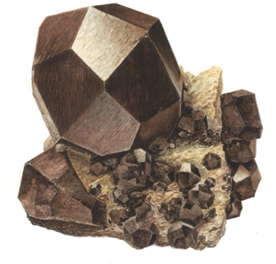

Watercolorpainting by Fred Wilda

One of the most valuable and much sought after mineral specimens
From Massachusetts, is referred to as “Russell Garnet”. The Garnets are said to be of the Almandine variety and formed in sharp trapezohedral crystals of substantial sizes. They were found during the excavation of a fire hydrant in about 1885, by Daniel Clark and
F. S. Johnson. They removed the crystals from a simple Pegmatite in a “secret” location in the vicinity of Russell, MA. Several specimens ended up in area museums. Some were said to have been polished using shoe polish, to further enhance the luster. But to add to the mystery, even the identification of the Garnets is in doubt. Specimens have been labeled Almandine, Spessartine or even Grossular or Melanite. Many collectors, even today, are still searching for the location because, though rare, good specimens can bring thousands of dollars. The site may be lost forever… but who knows?

GLOSSARY
Conglomerate:arockconsistingofpebblesorthelikeembeddedinafinercementingmaterial;consolidatedgravel. Dictionary.com
Fossils:anyremains,impression,ortraceofalivingthingofaformergeologicage,as a skeleton, footprint,etc.Dictionary.com
Igneous Rock:A rock formed through the melting, cooling and solidification of Magma. Intrusive Igneous Rock does not get exposed to the surface, but cools slowly underground.Granite is an Intrusive Igneous Rock. Extrusive Igneous Rock cools quickly above ground. An example is Basalt.

Silicate:The silicate minerals make up the largest and most important class of rock-forming minerals, constituting approximately 90 percent of the crust of the Earth. They are classified based on the structure of their silicate group which contains different ratios of silicon and oxygen.
Sedimentary Rock:Rockthathasformedthroughthedepositionandsolidificationofsediment,especiallysedimenttransportedbywater(rivers,lakes,andoceans),ice (glaciers), andwind.Sedimentaryrocksareoftendepositedinlayers,andfrequentlycontain fossils. Dictionary.com
Metamorphic Rocks:The name for rocks that have been changed by heat and pressure is Metamorphic.Metamorphic comes from Greek words meaning "change" and "form" Metamorphic rocks form deep in the earth where high temperature,great pressure and chemical reactions cause one type of rock to change into another type of rock.

Ore:is a type of rock that contains minerals with important elements including metals. The ores are extracted through mining; these are then refined in various ways to extract the valuable element(s).

Pegmatites: are various coarse-grained igneous rocks that form crystals of one centimeter or larger. They form from water-rich magmas that cool slowly, allowing the crystals to grow to large sizes.

MINERALS OF MASSACHUSETTS

Acanthite
Actinolite
Actinolite-Tremolite Series
Aegirine
Aegirine-augite
Aenigmatite
Aglaite
Akaganeite
Alabandite
Albite
Albite-Anorthite Series
v: Andesine
v: Cleavelandite
v: Oligoclase
v: Oligoclase-Albite
v: Pericline
Allanite
Allanite-(Ce)
Alleghanyite
Allophane
Almandine
Almandine-Spessartine Series
Alum Group
Alunogen
Amber
Amesite (TL)
Amphibole Supergroup
v: Byssolite
v: Uralite
Analcime
Anatase
Andalusite
v: Chiastolite
Andradite
Andradite-Grossular Series
Anglesite
Anhydrite
Ankerite
Annite (TL)
Anorthite
v: Labradorite
Anorthoclase
Anthophyllite
Antigorite
v: Bowenite
v: Picrolite
Apatite
Apophyllite
Aragonite
Arsenopyrite
Asbestos
Asphaltum
v: Albertite
Astrophyllite
Augite
v: TitanianAugite
Aurichalcite
Autunite
Axinite-(Fe)
Axinite Group
Azurite
Babingtonite
Bafertisite
Baryte
Bassanite
Bauxite
Bementite
Bertrandite
Beryl
v: Aquamarine
v: Goshenite
v: Heliodor
v: Morganite
Biotite
Birnessite
Bornite
Britholite-(Ce)
Brochantite
Brodrickite
Brookite
Brucite
v: Nemalite
Calcite
v: Argentine
v: Calcite Satin Spar
Caledonite
Cancrinite
Carbonate-cyanotrichite
Caryopilite
Cassiterite
Cerussite
Chabazite
v: Phacolite
Chabazite-Ca
Chabazite-K
Chalcanthite
Chalcocite
Chalcopyrite
Chamosite
v: Corundophilite
Chert
Chevkinite-(Ce)
Chlorite Group
Chloritoid
Chlorophaeite
Chondrodite Chromite
Chrysocolla
Chrysotile
Clay
Clinochlore
v: Delessite
v: Diabantite
v: Sheridanite
Clinohumite
Clinopyroxene Subgroup
Clinozoisite
Coal
v: Anthracite
Cobaltite
Columbite
Columbite-(Fe)
Columbite-(Mn)
Columbite-Tantalite
Copiapite
Copper
Cordierite
Corundum
v: Sapphire
v: Ruby
Covellite
Cristobalite
Cryophyllite
Cryptomelane
Cubanite
Cummingtonite
Cuprite
v: Chalcotrichite
Cymatolite
Danalite (TL)
Datolite
v: Botryolite
Diadochite
Diaoyudaoite
Diaspore
Diatomaceous Earth
Dickite
Diopside
v: Diallage
Djurleite
Dolomite
v: Ferroan Dolomite
Dravite
Elbaite
Emery
Enstatite
Epididymite
Epidote
Epidote Group
Epsomite
Fayalite
Feldspar Group
Fergusonite
Fergusonite-(Y)
Ferrihydrite
Ferrisicklerite
Ferro-anthophyllite
Ferrohexahydrite
Ferro-hornblende
Ferro-kaersutite
Fluorapatite
Fluorite
v: Yttrocerite
Forsterite
Gadolinite
Gahnite
Galena
v: Argentiferous Galena
Garnet
Gedrite
Geikielite
Genthelvite
Gibbsite (TL)
Glauconite
Goethite
Gold
Goslarite
Graphite
Grossular
v: Hessonite
Grunerite
Gummite
Gypsum
v: Selenite
Halite
Halloysite
Halotrichite
Harmotome
Hastingsite
v: Alkali-ferrohastingsite
Hedenbergite
Hematite
v: Iron Rose
v: Specularite
Hemimorphite
Heterosite
Heulandite
Hexahydrite
Hornblende
Hubnerite
Hydrobasaluminite
Hydrocerussite
Hydroxylherderite
Hydrozincite
Hypersthene
Iddingsite
Ilmenite
v: Manaccanite
Jacobsite
Jarosite
Kaersutite
Kamphaugite-(Y)
Kaolinite
Kerolite
K Feldspar
v: Adularia
Kutnohorite
Kyanite
Langite
Laumontite
Lazulite
Leadhillite
Lechatelierite
v: Fulgurite
Lepidocrocite
Lepidolite
Lepidomelane
Leucoxene
Limonite
Linarite
Litharge
Lizardite
Lˆllingite
Maghemite
Magnesio-hornblende
Magnesite
v: FerroanMagnesite
Magnetite
v: Titaniferous Magnetite
Malachite
Manganese Oxides
v: Manganese Dendrites
Marcasite
Margarite
Marialite
Meionite
v: Nuttallite
Melanterite
Mendipite
Meta-autunite
Metatorbernite
Mica Group
Microcline
v: Amazonite
Microlite Group (TL)
Mimetite
Minnesotaite
Molybdenite
Monazite
Monazite-(Ce)
Montebrasite
Montmorillonite
Muscovite
v: Fuchsite
v: Illite
v: Sericite
Natrolite
Neotocite
Nepheline
Oligoclase-Andesine
Olivine
Opal
v: Opal-AN
Orthoclase
OttrÈlite
Paragonite
Pargasite
Parisite-(Ce)
Pectolite
Pentlandite
Percylite
Perthite
Phenakite
Phlogopite
Phosgenite
Pickeringite
Piemontite
Pigeonite
Pinite
Plumbogummite
Pollucite
Polybasite
Polydymite
Prehnite
Prochlorite
Psilomelane
Pumpellyite
Pyrargyrite
Pyrite
Pyrolusite
Pyromorphite
Pyrophanite
Pyrophyllite
Pyroxene Group
Pyrrhotite
v: NickeloanPyrrhotite
Quartz
v: Agate
Quartz
v: Amethyst
v: Basanite
v: Blue Quartz
v: Carnelian
v: Chalcedony
v: Citrine
v: Jasper
v: Milky Quartz
v: Prase
v: Rock Crystal
v: Rose Quartz
v: Sceptre Quartz
v: Smoky Quartz
RanciÈite
Rhodochrosite
Rhodonite
Richmondite (of Kenngott)
Riebeckite
Riebeckite Group
v: Crocidolite
Rockbridgeite
Rˆntgenite-(Ce)
Rozenite
Rutile
v: Ilmenorutile
Sanidine
Saponite
v: Bowlingite
Scapolite
v: Wernerite
Scapolite Group
Schallerite
Scheelite
v: Molybdoscheelite
Schorl
Schwertmannite
Scolecite
Serpentine Group
v: Marmolite
v: Retinalite
Siderite
v: Manganoan Siderite
Siderotil
Sillimanite
Silver
Smectite Group
Smithsonite
Soapstone
Sodalite
Sonolite
Spessartine
Sphalerite
Spinel
v: Pleonaste
Spodumene
Staurolite
Stellerite
Stephanite
Stibnite
Stilbite
Stilbite-Ca
Stilpnomelane
Sulphur
Synchysite-(Ce)
Takanelite
Talc
v: Steatite
Tantalite
Tektite'
Tellurobismuthite
Tephroite
Tetradymite
Tetrahedrite
Thomsonite-Ca
Thorite
v: Orangite
Thorogummite
Titanite
Topaz
Torbernite
Tourmaline
v: Indicolite
v: Verdelite
v: Watermelon Tourmaline
Tremolite
Triphylite
Turgite
Uraninite
Uranophane
Uvite
Vermiculite (TL)
Vesuvianite
Violarite
Vivianite
Wad
Witherite
Wollastonite
Wroewolfeite (TL)
Wulfenite
Wurtzite
Xenotime-(Y)
Zeolite Group
Zircon
v: Cyrtolite
Zirconolite
v: Polymignite
Zoisite

REFERENCE MATERIAL CREDITS

A Field Guide to Rocks and Mineralsby Pough
American Journal Experts
http://www.aje.com
Bureau of Mines – U.S. Dept of the Interior
Guide to Rocks and Minerals - Simon & Schuster’s
Loudville Lead Mines by Peter J. Dunn and John H. Marshall, Jr.
Mindat
http://www.mindat.org
Nash Dinosaur Track Site and Rock Shop, http://www.nashdinosaurtracks.com
Russ Behnke Minerals
http://www.russbehnke.com
Western Massachusetts Mineral Localities by Alan R. Plante

